**Day 79 Goals: what you will make by the end of the day**

**Your Story**

Today you will become a doctor, but not just any doctor. You will become Dr Ignaz Semmelweis, a Hungarian physician born in 1818 who worked in the Vienna General Hospital.

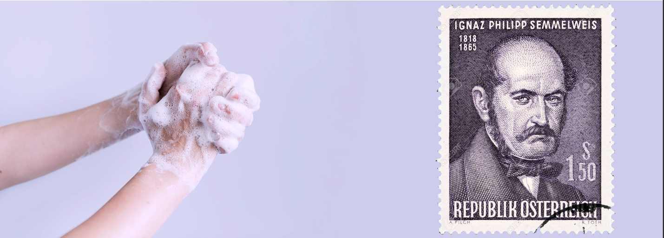

In the past, people didn't know about bacteria, germs, or viruses. People illness was caused by "bad air" or evil spirits. But in the 1800s Doctors started looking more at anatomy, doing autopsies and making arguments based on data. Dr Semmelweis suspected that something was going wrong with the procedures at Vienna General Hospital. Dr Semmelweis wanted to figure out why so many women in maternity wards were dying from childbed fever (i.e., [puerperal fever](https://en.wikipedia.org/wiki/Postpartum_infections)).

**Today you'll learn:**

* How to make a compelling argument using data
* How to superimpose histograms to show differences in distributions
* How to use a Kernel Density Estimate (KDE) to show a graphic estimate of a distribution.
* How to use scipy and test for statistical significance by looking at p-values.
* How to highlight different parts of a time series chart in Matplotib.
* How to add and configure a Legend in Matplotlib.
* Use NumPy's .where() function to process elements depending on a condition.

**Download and add the Notebook to Google Drive**

As usual, download the .zip file from this lesson and extract it. Add the .ipynb file into your Google Drive and open it as a Google Colaboratory notebook.

**Add the Data to the Notebook**

The .zip file also includes two .csv files. This is the data for the project. Add this file to your notebook.

Resources for this lecture